

**Industrialization of management with information technology – Hospital schedule management**

**Ho Hoang Long**

FPT University,

Ho Chi Minh, Vietnam

**Tran Phuong Linh**

FPT University,

Ho Chi Minh, Vietnam

***Abstract***

The purpose of the paper is to develop a process based on industry structure where information technology plays a core role in order to increase efficiency in the management. We will analyze the similarities between industries and managed by information technology. Apply the strengths found in developing a specific management process. By analyzing the problem, we will build a process based on the appropriate modules. Then we will compare the performance of new processes and traditional methods.

***Keywords:*** *Industrialization; management; information technology.*

**I.** **INTRODUCTION:**

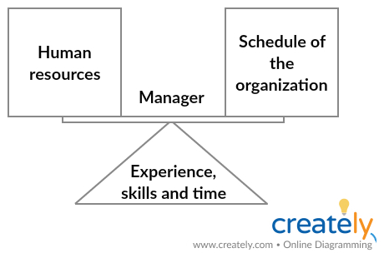

**Figure 1: Manager in human resources management**

**Status quo**

There are a number of limitations to existing HR management processes. The subject of management is still human. Managers must be able to capture the employee's workforce data, have a good grasp of the workflow of the team and have a certain experience in organizing and dividing the work. In addition, the process takes a long time for duplicate operations, while some low latency requirements are not met.

From an industrial perspective, if management is a manufacturing industry, then the traditional process is in the manual labor. To industrialize the process must adhere to the following characteristic:

* Divided production and centralized production.
* Standardization and mass production.
* Automate duplicates operations
* Integration of planning, production and distribution

**Specific problem**

To be more intuitive we analyze a particular problem. Managing hospital schedules from an industry perspective, we first look at the similarities:

|  |  |
| --- | --- |
| **Industry** | **Hospital HR management** |
| Manufacturing | Scheduling |
| Input materials | Human resources, hospital calendar |
| Output products | Shift scheduler, meeting scheduler, mission scheduler |
| Product distribution | Popular calendar for employees |

To improve performance and towards mass production have to process re-engineering with the aim of replacing manual labor with machinery and automating permanently recurring processes. The best solution to choose is to use information technology. It can be said that the role of information technology in the "management industry" is equivalent to the role of machinery in the industrial revolution.

**II.** **PROBLEM AND SOLUTION PLAN:**

To solve the problem, we need to develop a system that satisfies the hospital's requirements while meeting the following characteristics:

* Standardization
* Systematization
* Flexibilization
* Rationalization

**1. Process division:**

In some hospitals for reasons, data storage facilities must be stored on site. Besides the adjustment of the data and access the data still has to guarantee real time, and is not constrained by location. So the separation process into phases collect and store data, production and data processing, dissemination and access to information is essential.

**Product distribution**

**Reserve collect materials**

**Production**

**Figure 2: Process division**

**2. Transport:**

**Figure 3: Requirements of transport**



Problems when separating the base in that process is the generation of cost and transit time while ensuring the integrity of the goods during transport. The goods in this case are the data, we must build the transport system from the database through the processing system to the user interface. Fortunately, with the information technology, we have a very powerful “infrastructure” (internet) that will solve the problem of transport.

**3. Production separation**

In fact, the information processing performance is directly proportional to the experience and understanding of that information source. In fact, in order to create a reasonable schedule, we must combine three types of information: Human resource information, routine activities of each employee and schedule the activities of the hospital. It is difficult for a person to manage all three tasks. Why do not we separate them for each individual part to specialize?

**Figure 4: Information for hospital scheduling**

**4. Market demand analysis**

The important thing before getting started is whether the product is designed to meet the needs of the market. Based on the operating procedures of the hospital, our system must provide features that include:

* Manage user
* Manage department
* Manage meeting room resource
* Manage shift schedule
* Manage mission schedule + mobile notification service
* Manage meeting schedule
* Manage notification

**III. PLAN IMPLEMENTATION**

**1. Separate system:**

For easy access anywhere, the system will be built on the web application model. With cloud hosting service, the server will be hosted online and can be accessed by any valid client. To meet the demand for local database storage, we will separate the front end server and back end servers. The back end server will be responsible for data processing, query database, and local storage along with the database. The front end server will be responsible for displaying the data, communicating with the client, receiving and sending commands to the back end. Below is an example model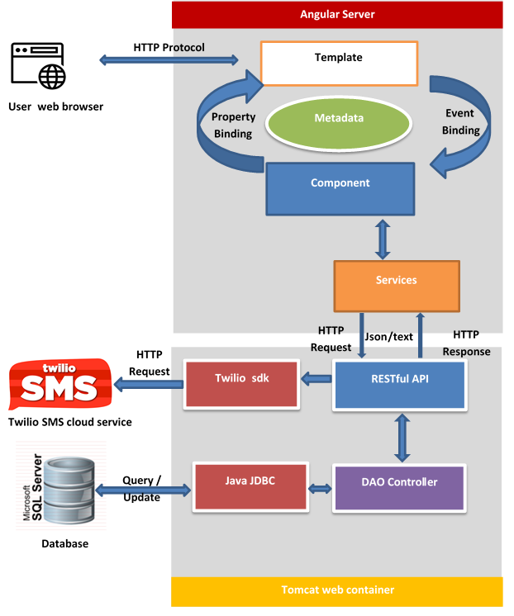

**Figure 4: Hospital Portal System architecture design**

Communication data will be standardized as json or XML. This supports the development of multi-interface and multi-language applications. Once the input and output information is standardized, it is easy to replace the front end server with any programming language without rebuilding the processor. You can even use CMS (Content Management System) by cloud SAAS (Software as a Service) as a front end server.

**2. HTTP Protocol – TCP/IP:**

The Http protocol will serve the transport of data for a very short period of time, at a low cost and ensuring data integrity.

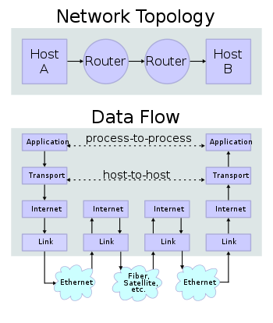

*“Two Internet hosts connected via two routers and the corresponding layers used at each hop. The application on each host executes read and write operations as if the processes were directly connected to each other by some kind of data pipe. Every other detail of the communication is hidden from each process. The underlying mechanisms that transmit data between the host computers are located in the lower protocol layers”*. *[1]*

*“The TCP is a connection-oriented protocol that addresses numerous reliability issues in providing a reliable byte stream:*

* *Data arrives in-order*
* *Data has minimal error (i.e., correctness)*
* *Duplicate data is discarded*
* *Lost or discarded packets are resent*
* *Includes traffic congestion control”[2]*

TCP at the source machine divides the bytes of the data into segments of appropriate size. Then, TCP passes these packets over the IP protocol to send them over a network to TCP on the destination machine. TCP checks for a missing packet by assigning each packet a Sequence Number. When the destination TCP receives, they send to the TCP source an acknowledgment message for the received packet successfully. A TCP source clock will report time-out if no acknowledgment is received within the time period with an RRT (Round Trip Time), and data (considered lost) will be returned.

**3. Build application**

**a. Standardized data:**

Standardization is the digitization of data, including:

* Identify objects
* Determining properties of objects
* Identify relationships between objects
* Creates entities and databases

**b. Build application structure**

According to each of the analyzed features, we construct the application structure as follows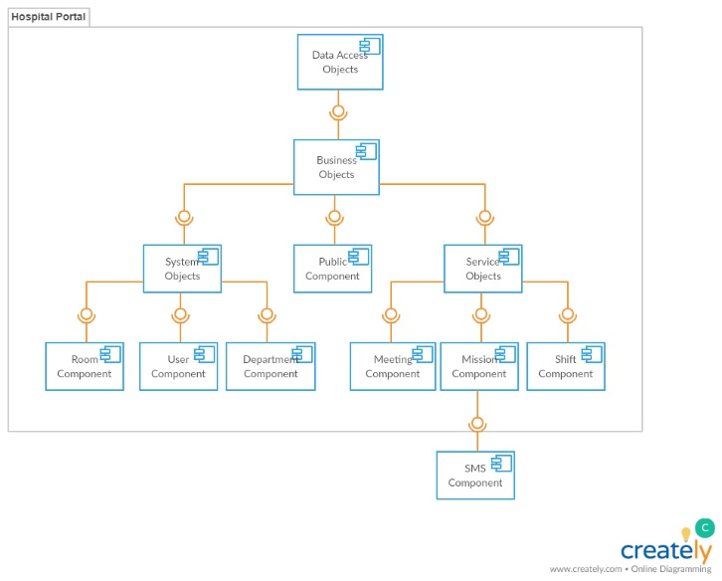

**Figure 4: Hospital Portal Component diagram**

**c. Division of roles**

Based on the analysis above, we will split the schedule generation process into three main tasks:

* Information resource management (user, department, room) for Human Resource Management Department (Admin)
* Manage the division of calendars to suit the daily schedule of each member in the department for dean.(Scheduler)
* Check calendars created to fit the hospital's total schedule for planning department. (Manager)

Besides the staff have the right to log into the system to look up schedule. (User)

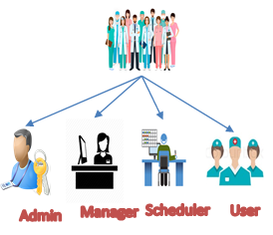

**Figure 5: User Role**

**d. Realization process**

The scheduler will create a schedule based on the data (user, department, room) created previously by the admin. The schedule after creation will be stored on the system in the waiting state. Manager access to the system, based on the schedule of the hospital that accepts or deny this schedule. Schedule after approved will be posted to the system, which users can access to view.

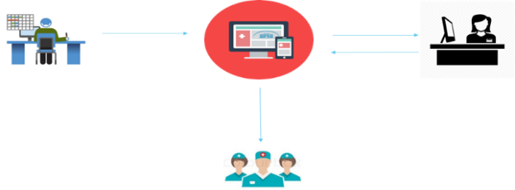

**Figure 6: Hospital Portal scheduling process**

**IV. ANALYSIS**

After the industrialization of the process of management by information technology we have built a system that acts as an electronic information portal. Where all the operations, editing, scheduling can work online and fast. The new system minimizes time, cost and human resources. At the same time digitizing data will facilitate the storage and development of other management applications later.

**V. EXPERIMENTAL RESULTS AND CONCLUSION**

Based on the above system structure, we have created an application called Hospital Portal. By this application, we succeed in completely eliminating paperwork in the calendar management process. The application process satisfies most of the tasks required on the network environment. Using the Internet and SMS cloud service, our application is more immediate than the traditional process

**ACKNOWLEDGMENT**

Gerhard Girmscheid “Industrialization in Building Construction – Production Technology or Management Concept” Institute for Construction Engineering and Management, Swiss Federal Institute of Technology Zurich

**REFERENCES**

*[1], [2] at Wikipedia Internet protocol suite*[*https://en.wikipedia.org/wiki/Internet_protocol_suite*](https://en.wikipedia.org/wiki/Internet_protocol_suite)